Gazi University DG Khan
Name : Maheen Fatima
BsCs 1st semester section D
Roll number:13
Submitted to:Mr Asad Majeed
Programming fundamental
Lab #01
Task 01
Run the following program and cheak the output .
#include <iostream>
using namespace std;
int main( ){
cout<<"hello world"<< endl;
//ptint hello world and endl means end the line system ("pause"); // to stop output window
return 0;
}
Output ..
Hello world
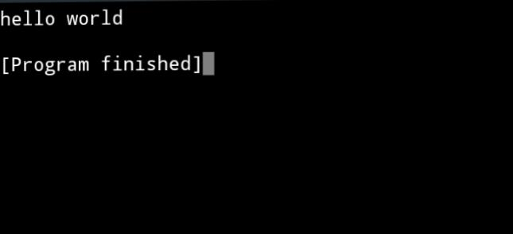

Task 02
Write the c++ program to run the following .
#include <iostream>
Using namespace std;

Int main() {
Int age;

Cout << “Enter your age: “;
Cin >> age;

If (age < 18) {
Cout << “You are “ << age << “ year old.” << endl;
Cout << “You are too young to play the game.” << endl;
} else {
Cout << “You are old enough to play the game.” << endl;
}

Return 0;
}
Output...
10: 10
You are 10 year old.
You are too young to play the game.

[Program finished]
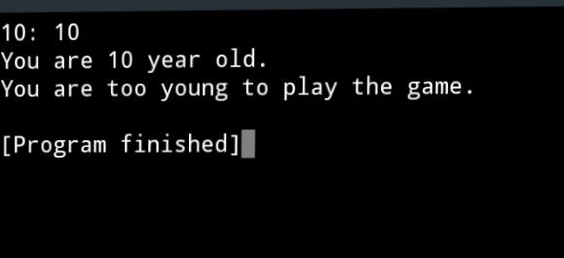

Task 03

Write a c++ program to print the following lines:
*
**
***
****
*****
#include<iostream>
using namespace std;
int main() {
cout<<"*"<<endl;
cout<<"**"<<endl;
cout<<"***"<<endl;
cout<<"****"<<endl;
cout<<"*****"<<endl;
return 0;
}
Output ....
*
**
***
****
*****
